**BOLETÍN DE PT PARA ….**

|  |  |  |  |  |
| --- | --- | --- | --- | --- |
|  |  |  |  |  |
| DISFRUTA EN CLASE | ES PARTICIPATIVO |

|  |  |  |  |  |
| --- | --- | --- | --- | --- |
|  |  |  |  |  |
| PIDE AYUDA | ESCUCHA ATENTAMENTE |

|  |  |  |  |  |
| --- | --- | --- | --- | --- |
|  |  |  |  |  |
| SIGUE INDICACIONES | SE ESFUERZA |

|  |  |  |  |  |
| --- | --- | --- | --- | --- |
|  |  |  | LISTA DE MATERIAL ESCOLAR ADAPTADA. | Ideas de AL y PT |  |
| RECOGE | CUIDA EL MATERIAL |

|  |  |  |  |  |
| --- | --- | --- | --- | --- |
|  |  |  |  |  |
| REALIZA LAS ACTIVIDADES |  | RESPETA A LOS DEMÁS |

|  |  |  |  |
| --- | --- | --- | --- |
| Bitmoji Image | Bitmoji Image | adulting |  |
| SIEMPRE | CASI SIEMPRE | A VECES | TÚ PUEDES |

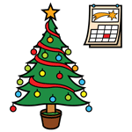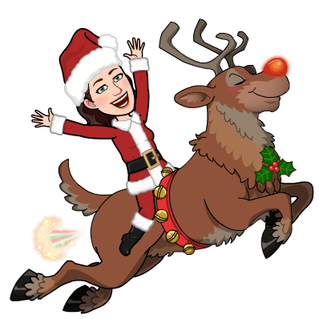

FELIZ NAVIDAD

SEÑO YOLANDA